22) Create wireframes illustrating how localization features can be integrated into a mobile app, ensuring a user-friendly design in Figma.

Aim:Wireframes illustrating how localization features can be integrated into a mobile app using Figma
Procedure: -
- Open Figma
- Create a new file
- Select the Frames
- Design Visual Elements
- Make it Interactive
- Add icons on the Frame
- Incorporate Multimedia
- Storyboard Animation
- Review and edit the Prototype
- Save and Share

Design:
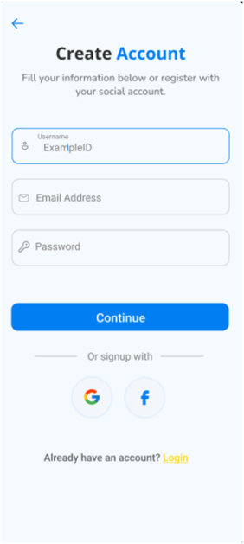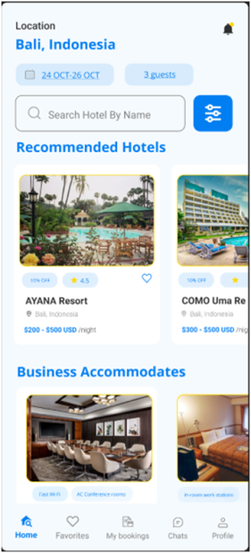
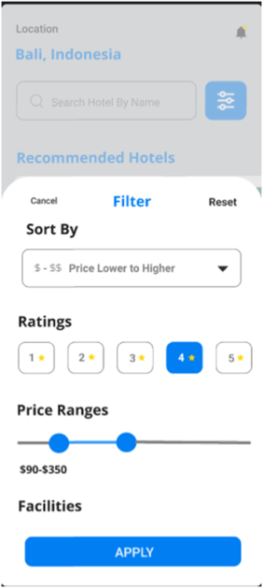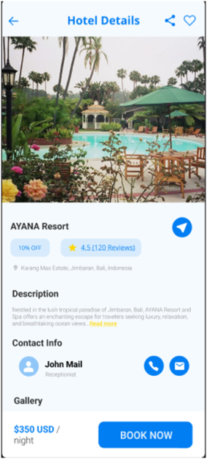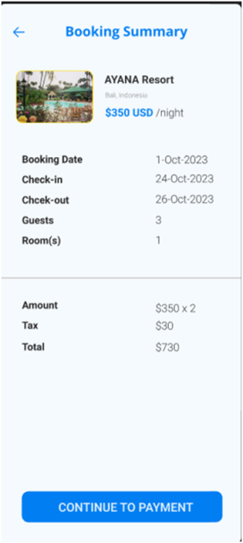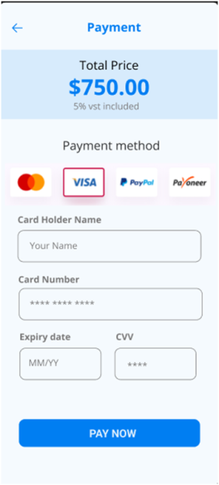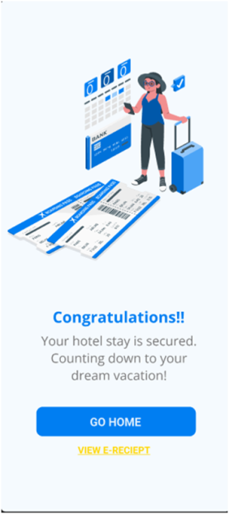

Prototype: -
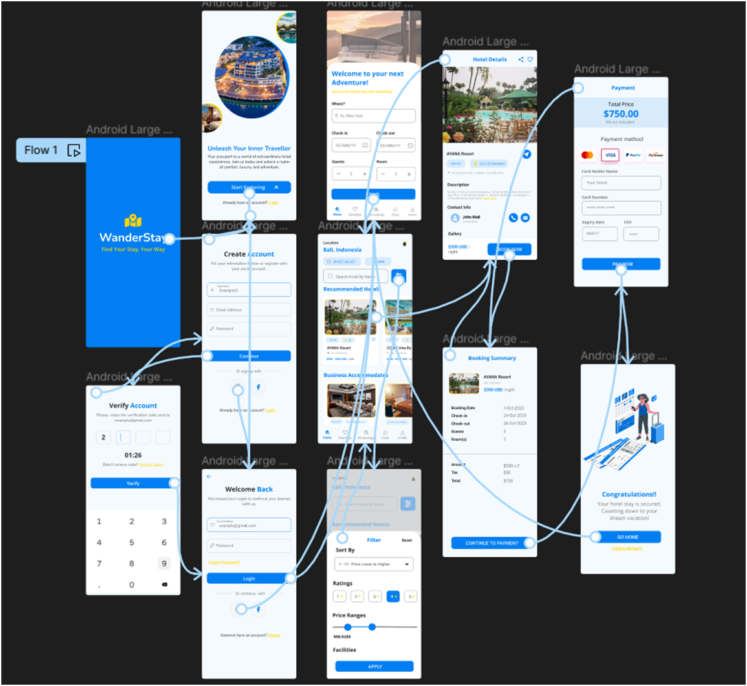
Result: -
Hence the localization features can be integrated into a mobile app is created and executed successfully

